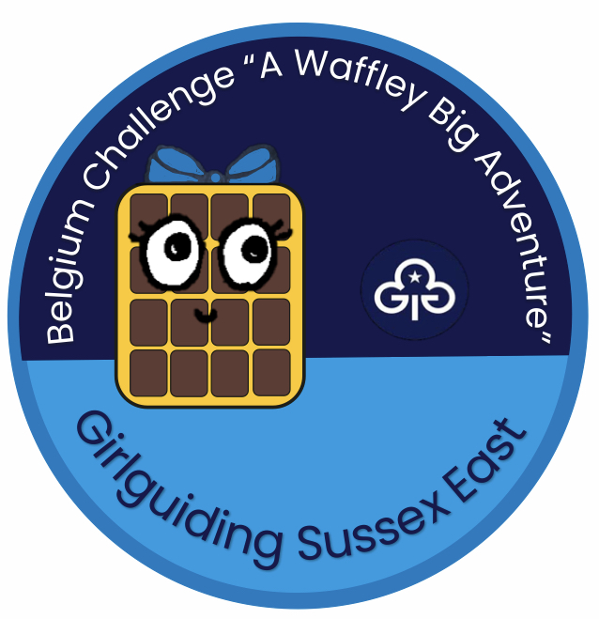

This badge has been designed to raise funds for Guides and Rangers from Sussex East County going on the 2023 “Breakaway to Belgium” trip.
Any surplus monies will go towards future trips.

Belgium challenge badge

Rainbows choose 1 clause from section 1 and any other 3
Brownies choose 1 clause from section 1 and any other 4
Guides and Senior Section choose at least 1 clause from section 1 and any other 5.

Section 1: Waffles!

Belgium is famous for Waffles.
- Make your own waffles (Recipe p6). N.B. you will need a waffle maker.
- Sample different types of ready-made waffle such as Stroop waffles, Liege waffles and Brussels waffles. Have a vote in your Unit on which one is best.
- Buy some ready-made waffles and try them with different toppings (See p6 for ideas).
- Knit a Waffle dishcloth https://homespunliving.blogspot.com/2007/11/waffle-knit-dishcloth-pattern.html
- Weave a waffle out of brown paper (instructions p7) and add collage toppings cut from magazines

Section 2: Belgian Food

- Despite their name, French Fries are thought to have originated in Belgium, where they are very much a national snack. The Belgians prefer them with mayonnaise. Go on a chip walk or otherwise sample chips with different sauces. Take a vote. Which does your Unit prefer?
- Research and make a traditional Belgian cake like ‘Javanais’ https://spajzgirl.wordpress.com/2011/12/30/two-fancy-belgian-cakes-2/ or ‘Miserable’ https://bake-street.com/en/le-miserable-belgian-cake/
- Have a chocolate tasting evening.
- Brussels Sprouts. Named after the Capital of Belgium these are one of the least popular vegetables. Try out the recipe on the link and see if it makes them more palatable. https://www.simplyrecipes.com/search?q=Brussels+sprouts

Section 3: Belgian Lace

Belgium is famous for lace made traditionally using lace pillows and bobbins.
- Invite a lace maker to talk to your Unit and demonstrate the art of lace making.
- Make a lace hair bow. There are lots of tutorials online like this one http://www.craftelf.com/General_Lace_Hair_Bow_craft.htm#axzz7xNRlvdYO
- Decorate a jam jar with lace or paper doilies to make a vase or tealight holder. There are many ideas online like this http://lovewedbliss.com/wedding-diy/diy-wedding-projects/how-to-make-lace-mason-jars/
- Print out the Belgium doll from the pattern below (pp8&9) colour in the clothes and dress the doll up. You could use a doily to collage the lace apron and cap.

Section 4: Belgian (Flemmish) artists

- Rene Magritte was a Belgian surrealist painter. Follow the instructions below (p10) to make a picture in the style of his painting “The False Mirror”
https://www.moma.org/collection/works/78938
- Peter Paul Rubens (“Rubens”) established a style of painting large colourful works, however he also did so many sketches he had to employ apprentices to finish them. Many of these were of animals. Use pencils to create your own animal sketch. https://www.wikiart.org/en/peter-paul-rubens/etude-of-lion-1620
- Pieter Breugel painted a picture called ‘Children’s Games’ https://en.wikipedia.org/wiki/Children%27s_Games_(Bruegel)
See how many of the games listed (p10) you can see in the picture and try some out.
- Jan Van Eyck. The Arnofini Wedding is one of the most famous paintings by the 15th century artist Jan Van Eyck. Almost every detail is a symbol. See if you can spot them all (p11)

Section 5: The Country of Belgium

- Do the true or false quiz (pp12&13) with your Unit.
- Do the Belgium Word Search (p14)
- The EU parliament meets in Brussels. Use the flags of the EU in the annexe to play flag games:
- have a competition to see who can identify the most
OR
- print off the flags several times and make cards to play flag bingo
OR
- enlarge images and cut into 4 pieces. Take 1 piece each (leader having hidden the rest) and see who can find and assemble theirs first. Work in small groups or as individuals.
- The Atomium https://www.atomium.be/home/Index is a famous modern building in Brussels. Have fun trying to make a replica Atomium building out of spaghetti and marshmallows.
- The official languages of Belgium are German, French and Dutch.
  - Learn how to say Hello, Goodbye, my name is..., and how are you in German French or Dutch
  - Make a small phrase book in any one of those three languages.

Section 6: Belgians in Fiction

- Hercule Poirot is a famous Belgian detective created by Agatha Christie.
  - Hold a murder mystery evening.
or
  - play a game of Cluedo or wink murder.

- The creator of Tintin, Herge, was Belgian.
The FILM “The Adventures of Tintin: the secret of the Unicorn” involves a treasure hunt. Organise a Tintin themed treasure hunt with your Unit.

- The Smurfs are Belgian in origin.
  - Hold a Smurf evening and get your Unit to dress up as Smurfs.
  - Colour a Smurf. Here is a link to a Smurf colouring pages http://www.coloring-book.info/coloring/coloring_page.php?id=117
  - Smurf names are based on adjectives which sum up their characteristics. Design your own Smurf (p15)

Waffle Recipe
Ingredients:
250g Flour (plain)
4tsp Baking powder
20g caster sugar
5g salt
475ml milk
2 Eggs
30ml Vegetable oil
1 tsp vanilla essence

Method
- Weigh all the dry ingredients, place in a large mixing bowl.
- Break the eggs into the milk and beat the mixture. Add vanilla.
- Add the egg and milk mixture to the dry ingredients. Add the oil and mix all ingredients together until all the large lumps have been broken up. Do not over mix otherwise the waffles will be heavy when cooked.
- Pre heat the waffle maker and spray with oil (1 cal spray works well).
- Pour 3/4 of a cup of batter into the waffle maker and cook for 3-4 mins or until golden brown and crispy on the outside.
Serve hot with maple syrup or the topping of your choice. Cooked waffles can be frozen and heated up in the toaster. Unused batter mixture can be kept in a container in the fridge for up to 2 days.
Waffle Toppings
Strawberries and whipped cream
Blueberries
Chocolate Chips
Bananas and nuts
Nutella
Apricot Jam
Raspberries …
Weave A Waffle Mat
- take an A4 size piece of brown construction paper and mark a border 2cm from the edge all the way round
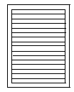
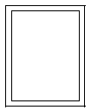
- Draw lines 2cm apart

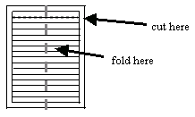
- Fold in half length wise and cut along the lines. Make sure not to cut into the border you drew!

- Take another sheet of paper in a different shade of brown and cut into strips length ways
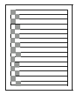
- Thread the paper strips through the slits in your first piece, taking each strip UNDER one strand, then OVER the next one. When you add more strips, make sure you reverse the pattern, going OVER the strand you went UNDER last time.

- Glue the strips in place at the border.

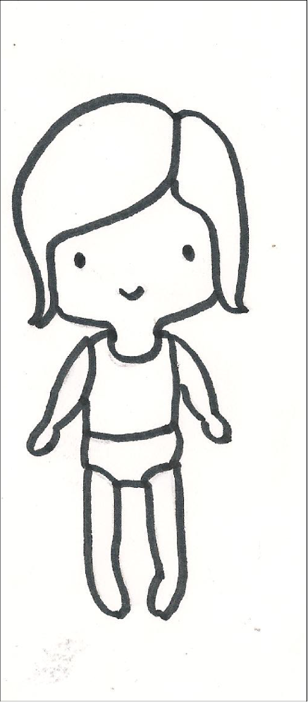

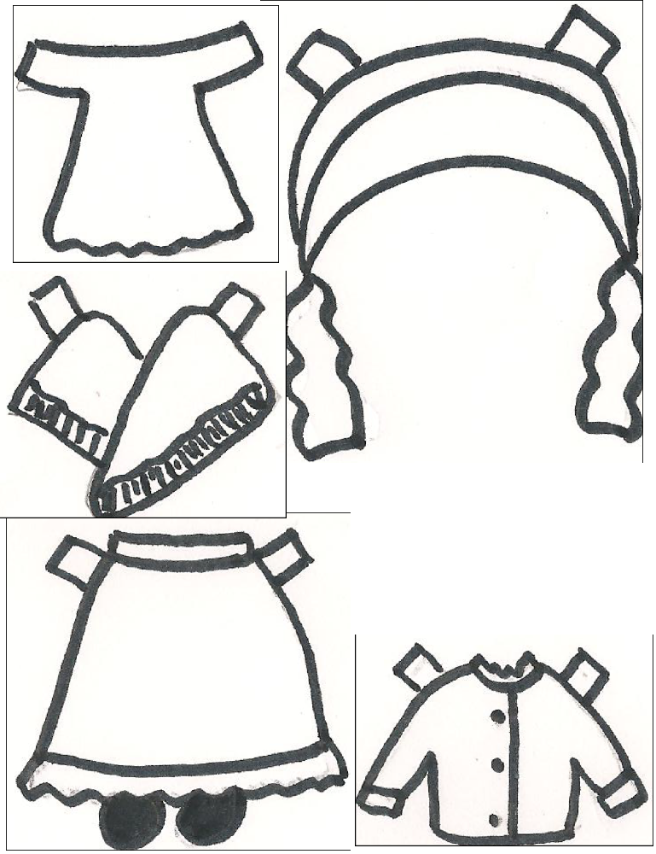

The False Mirror

Take an old CD and trace it in the center of an A4 paper. Add lines around the circle to turn it into an eye, including eyelashes.
2. Trace all the pencil lines with a black marker.
3. Draw an image inside the eye which reflects something you like to look at. This could be anything BUT the drawing of the inside of an eye. The more mysterious, the better! Colour all the shapes with coloured pencils.

Children’s Games to spot and to try:
  - Marbles
  - knuckle bones or jacks
  - blind mans’ buff
  - blowing soap bubbles
  - ladders http://genkienglish.net/ladders.htm
  - stilt walking
  - spinning tops
  - Rolling hoops
  - ball against the wall (sevens) http://www.eenymeeny.net/games/ball%20games/Sevens.html

The Arnofini Wedding

Symbolic candle
The single flame burning in bright daylight might be a bridal candle, or a symbol of God's all-seeing eye, or simply as a devotional candle.
A signature
Like today, marriages in 15th-century Flanders could take place privately rather than in church. Van Eyck's Latin signature reads: ``Jan van Eyck was present'', and has been interpreted by some as an indication that the he served as a witness at the wedding.
Convex mirror
The mirror is painted with enormous skill. Its carved frame is inset with ten miniature medallions depicting scenes from the life of Christ. There’s more: the mirror's reflection, which includes van Eyck's own tiny self-portrait, accompanied by another man who may have been the official witness to the ceremony.
The Dog
The companion dog is seen as a symbol of faithfulness and love and as an expensive breed it was also a sign of the couple’s wealth.
Oranges
The fruits on the window ledge probably stand for fertility: a wish that the couple are blessed with children they could also be a sign of the couple’s wealth.
The Groom’s Shoes
Even the discarded shoes are not thought to be incidental, but to symbolize the sanctity of marriage.
True or false quiz

  - over fifty per cent of billiards balls are made in Belgium.
  - oil painting was invented in Belgium.
  - chips were invented in Belgium.
  - Belgium sells the least chocolate in the world.
  - there are six types of Belgium waffles.
  - there are no skyscrapers in Belgium.
  - Belgium has no MacDonald’s restaurants.
  - Belgium was the second country to ban forced marriage.
  - Charlemagne came from Belgium.
  - Belgium has the biggest gap between male and female salaries.
  - voting is compulsory in Belgium.
  - the Belgium motorway system can be seen from the moon.
  - there is no cable TV in Belgium
  - Belgium has the smallest town in the world.
  - the saxophone was invented in Belgium.
  - pralines were not invented in Belgium.

Answers to true or false quiz
  - true
  - true
  - true
  - false
  - false
  - false
  - false
  - true
  - true
  - false
  - true
  - true
  - false
  - true
  - true
  - false

Belgium Word Search
B E L G I U M A E T O E S Q R
Y B C H I H R O U U T T M A E
L A C E P D E H R O J Y U G B
Y C N S E F F N O R A B R O V
J S H N R L L X P P B E F D F
E G N O W E F E E S H J E W P
N E P B C Z D F M A J D T S S
S Y M A Y O N N A I S E T E H
N Q N C X F L R A W S M E N D
J G R A E N T A K L U H F I L
S L E S S U R B T I F R V L A
G H H R D B V P M E I Y F A Y
T O R I O P W O S T Q S T R V
H B Z J A I T H E S P X U P O
C L H Z L A Y S H S H J L B Z

ARDENNES
ATOMIUM
BELGIUM
BRUSSELS
CHOCOLATE
EUROPE
FLANDERS
FLEMISH
FRITES
HERGE
LACE
MAYONNAISE
POIROT
PRALINES
SMURFETTE
SPROUT
WAFFLE
My Smurf

Draw a Smurf that you would like to have living in your Smurf Village.

What is your Smurf’s name?

What are the characteristics of your Smurf (e.g. Brainy Smurf is very clever Chef Smurf cooks delicious food)
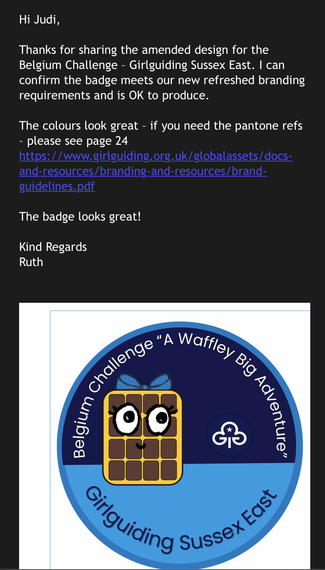
Badge Order Form
Your Details
Contact Name |  |  | Date of Order
Address |  |  | Email Address
Postcode |  |  | Unit Name
Country if not UK |  |  | Phone Number
Your Order
Number of Badges
Total Cost for Badges (@ £1.50 each)
Postage and Packing
Location | No Badges | P&P | No Badges | P&P | No Badges | P&P
UK | 1-5 | £1.00 | 6-49 | £2.50 | 50-100 | £4.00
Europe | 1-5 | £2.50 | 6-49 | £5.00 | 50-100 | £7.00
Worldwide | 1-5 | £3.50 | 6-49 | £7.00 | 50-100 | £9.00

Total Cost (Please add up Total Cost for Badges and Postage and Packing)
Payment Method (please tick how you’re paying)
Cheque |  | Payable to: Girlguiding Sussex East
BACS |  | Bank: Barclays  Account - Girlguiding Sussex East  Sort code - 202794  Account number - 93935965  Please state your Ref as “AWBA unit name”

Please send order form by email: Judi.Gott1@btinternet.com
Or post to: The Martello Tower, Leyland Road, Pevensey Bay, East Sussex, BN24 6HT
Orders will be sent by 2nd Class post for those in the UK or ‘International Standard’ for orders going to Europe or elsewhere in the world. We aim to post out twice a month. Please e-mail if you have not received your order.

