1st Response Factsheet: Asthma
Asthma is a chronic (long-term) condition in which the muscles of the air passages go into spasm making the airways narrow and causing the patient to have difficulty in breathing.
Signs and symptoms
- Difficulty breathing – short sentences and whispering
- Wheezing
- Coughing
- Distress and anxiety
- Grey-blue tinge to lips, earlobes and nailbed
- Exhaustion in a severe attack

Treatment
If a person with asthma is experiencing breathing difficulties, we should help them to use their own reliever inhaler, using a spacer device if one is available.
One puff of reliever inhaler every 30-60 seconds for up to 10 puffs. Use spacer device if available. Call for help if no improvement after 10 puffs. The 10 puff routine can be repeated after a few minutes if ambulance hasn’t arrived.
Some asthmatics now use a combination (MART/AIR) inhaler as both their reliever and maintenance therapy - they should use this during an asthma attack. This may not be a pump (like the one in the picture), and may be inhaled without a spacer. They can still take 1-2 puffs every minute, but the maximum doses can vary and so it's important to check with them/their parent/guardian and record this in their adjustment plan.
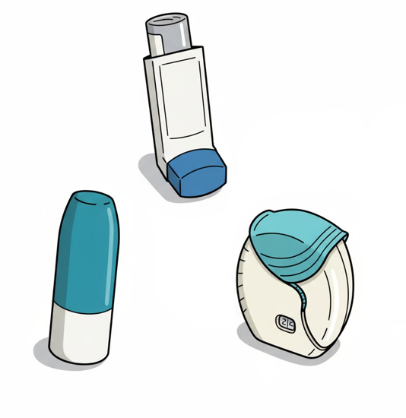
‘Red Flags’
Call 999/112 for medical help if:
- Reliever inhaler not easing attack
- Patient is becoming exhausted
- Patient is too breathless to speak
- Patient cannot complete full sentences

