1st Response Factsheet: Tick Removal
Ticks can transmit bacteria that cause diseases such as Lyme disease. Lyme disease can cause serious problems such as nerve damage and arthritis. Not all tick bites can lead to illness, but it is important to know how to avoid tick bites and what to do if somebody gets bitten, as prevention and early detection are crucial.
Ticks are often found in dense vegetation or long grass, and climb onto people as they brush past them. They bite to attach to the skin and start to feed on the blood..
People don’t always know they’ve been bitten so it is important to check thoroughly. Look over clothes or body for any ticks to brush off. Ticks prefer warm moist places such as groin area, waist, arm pits, behind the knee or along the hairline. You’re looking out for anything as tiny as a freckle or speck of dirt. This will need to be handled sensitively and appropriately in a residential setting.

How to avoid tick bites
To reduce the chance of being bitten by a tick:
- cover your skin while walking outdoors and tuck your trousers into your socks
- use insect repellent on your clothes and skin – products containing DEET are best
- stay on clear paths whenever possible
- wear light-coloured clothing so ticks are easier to see and brush off

To remove a tick safely:
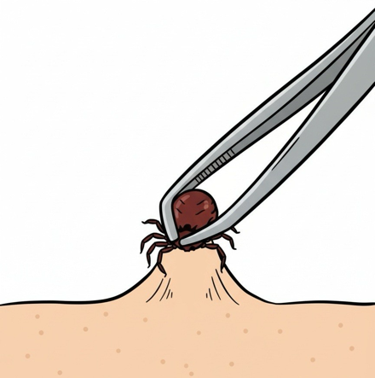
- Use fine-tipped tweezers or a tick-removal tool. You can buy these from some pharmacies, vets and pet shops.
- Grasp the tick as close to the skin as possible.
- Slowly pull upwards, taking care not to squeeze or crush the tick. Dispose of it when you have removed it.
- Clean the bite with antiseptic or soap and water.
- The chance of getting ill is low. You do not need to do anything else unless you notice a rash or become unwell.
- You can also watch a video on How to remove a tick

Symptoms of Lyme disease
- A circular or oval shape rash around a tick bite can be an early symptom of Lyme disease in some people.
- The rash can appear up to 3 months after being bitten by an infected tick but usually appears within 1 to 4 weeks. It can last for several weeks.
- Other symptoms include flu-like symptoms, fatigue, muscle and joint pain.
- It is easily treated with a course of antibiotics in the early stages.

