Safer Guiding Training

Which eLearning do I need to complete?
If you volunteer with girls, then you need to complete the Safer Guiding course.
The eLearning consists of 4 topics; each topic has smaller modules to complete, with a quiz at the end of each topic. The learning is designed to dip in and out of rather than trying to complete in one go. You must pass each of the four topic quizzes to pass the course.
If you do not have any direct contact with girls, then you need to complete the Safer Guiding Basics course. This takes around 45 mins and there is no quiz attached.
If you are unsure of which course you need to complete use this link to check Safer guiding training | Girlguiding

How long will it take me to complete the Safer Guiding eLearning?
In total the eLearning will take around 3 hours to complete and consists of the following topics
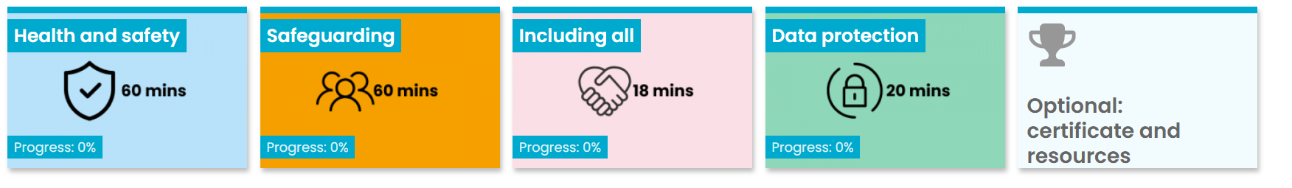
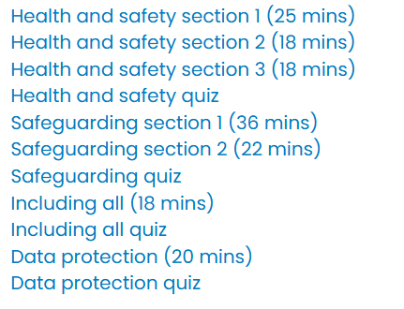
Once you have completed a module successfully a green tick will show against that module. You have three attempts to pass each quiz, if you fail the quiz a red cross will show against that quiz.

What happens if I fail a quiz?
You have three attempts at each quiz. If you fail a quiz, you still need to carry on with the rest of the eLearning until each module has a green or red tick against them.
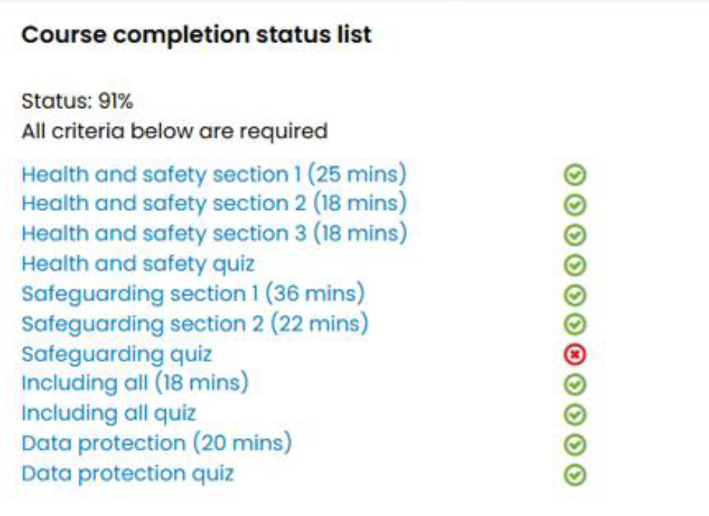
If you fail one quiz, as in the diagram above, you will need to contact ggsussexeasttraining@hotmail.com including a screen shot of the course status in your email, and we will arrange for a Safer Guiding trainer to meet with you to cover the relevant modules in person.
What happens if I fail more than one quiz?
If you fail a second quiz you will be required to attend a trainer led session. These are currently being offered as two webinar sessions via the Learning Platform, each lasting approximately 2 hours or you can attend a trainer led session in County. See the County website and the Learning Platform for the next available course
Do I have to complete the Safer Guiding eLearning, can I attend a webinar or a face-to-face training instead?
You can attend a Safer guiding Webinar or a face-to-face session if one is available. Remember that you must attend both Session 1 and Session 2 of the webinars to complete the Safer Guiding training. A face-to-face training will take around 5/6 hours, including breaks, to complete.
What do I do if the course freezes and will not let me go any further?
This is a common issue, with parts of the eLearning. Firstly, check that you have opened every link on the page, and selected all the relevant tiles. Some of the videos must be watched to the very end (including the end credits) to be marked as completed. If you have tried all of this, contact membership systems and they will be able to unfreeze you.

